

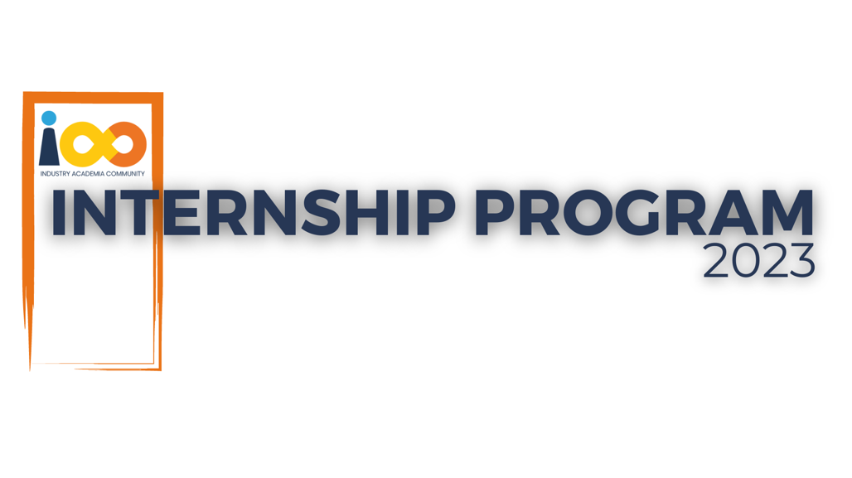

PROJECT REPORT

React Js  
  
Linkedin Replica

|  |  |  |  |
| --- | --- | --- | --- |
| **Created By:** | Utekar Pranit Ganesh | **Approved By:** | Manikanth Babu |
| **Created On:** | 23-09-2023 | **Approved On:** | 25-09-2023 |

Page left blank intentionally

**INDEX**

**1** **PROJECT DETAILS** 2

**2** **SUMMARY** 2

**3** **INTRODUCTION** 3

3.1 Background 3

3.2 Stakeholders 4

3.3 Objectives 4

**4** **METHODOLOGY** 5

4.1 Considerations & Assumption 5

4.2 Approach 5

4.3 Activities 5

**5** **TARGETTED V/S ACHIEVED OUTPUT** 6

**6** **CONCLUSION** 7

**7** **APPENDICES** 8

7.1 Appendix A – Title 8

**General Instructions for using the Live Project Report Template**

* This template and the subsequent document created using this template is a confidential document and is the intellectual property of Cloud Counselage Pvt. Ltd. Circulating it outside of the organisation without the consent of Cloud Counselage Pvt. Ltd. is the breach of company policies and will lead to legal actions
* This template is a guideline document to communicate the implementation of design ideas and the results of the work to the stakeholders.
* The **text between inequality (< >) is to be replaced** by relevant text
* Please **remove the yellow highlight on the Text** between the inequality (< >). This is done to help you notice the text to be changed/replaced
* The text in *italics* highlighted in grey is just for reference and should be removed after adding the relevant text

# **PROJECT DETAILS**

|  |  |  |  |
| --- | --- | --- | --- |
| **Project Name** | Linkedin Replica | | |
| **Project Sponsor** |  | | |
| **Project Manager** | Harshada Topale | | |
| **Start Date** | 31-07-2023 | **Completion Date** | 25-09-2023 |

# **SUMMARY**

**Project Deliverables:**

The LinkedIn Replica project aimed to deliver a fully functional web application that replicates the core features and functionalities of the LinkedIn professional networking platform. The project sought to provide users with the ability to create profiles, connect with professionals, share professional updates, search for jobs, and engage in a variety of networking activities. The key deliverables included user registration and login, profile management, a news feed, job postings, messaging, connections, and an events/news feed.

**Project Need:**

The project was necessitated by the increasing demand for a professional networking platform that could replicate the features and benefits of LinkedIn while offering more control and customization options to users. LinkedIn, being a leading platform in this space, has inspired professionals worldwide to connect, share insights, and seek career opportunities. However, there was a need for an alternative platform that could provide a similar experience with a focus on user privacy, control over data, and a modern, intuitive user interface.

**Long-Term Benefits:**

The long-term benefits of the LinkedIn Replica project encompass several aspects:

**Professional Networking:** Users have gained a platform for expanding their professional networks, connecting with peers, colleagues, and potential employers, ultimately enhancing career opportunities and growth.

**Privacy and Control:** The project addressed concerns related to user privacy by offering greater control over personal data and interactions, allowing users to customize their experience as they see fit.

**Career Advancement:** The availability of job postings and networking opportunities has enabled users to explore career advancement options and connect with organizations actively seeking talent.

**Skill Showcase:** Professionals can showcase their skills and achievements, making it easier for potential employers or collaborators to identify their qualifications.

**Community Engagement:** Users benefit from a community-centric platform where they can participate in events, share news, and engage in discussions relevant to their industries and interests.

**Educational Opportunities:** Access to a platform that fosters knowledge sharing and the dissemination of industry insights supports ongoing learning and professional development.

**Networking Ecosystem**: The project contributes to the creation of a diverse and vibrant networking ecosystem, promoting collaboration, idea sharing, and innovation.

In summary, the LinkedIn Replica project has successfully delivered a platform that meets the professional networking needs of users while emphasizing privacy, customization, and an engaging user experience. Its long-term benefits encompass career advancement, community engagement, and opportunities for continuous learning, ultimately contributing to the growth and development of professionals and industries alike.

# **INTRODUCTION**

## Background

Design a user interface for a Professional network on the internet. A site that is used to find the right job or internship, connect and strengthen professional relationships, and learn the skills you need to succeed in your career.

## Stakeholders

A platform for anyone who is looking to advance their career, This can include people from various professional business owners, students, and job seekers.

## Objectives

**The solution is a ‘Linkedin(replica)' using React.Js, that prompts them to include appropriate information relevant to the profile, you can showcase your professional life, milestones, skills and interests.**

Your website should take simple inputs like login-page,sign-up,user registration, profile section, search bar, job postings, notifications, connections, messaging, events, news feed, etc. on the website. Once the information is submitted, the user can connect, share, join-groups apply to jobs by which their news feed & notofications will be populated. Finally, the web application will take information from the users through a Postings and put it into a standard view, and in the output, it will provide the feed of their post in the news feed or notified in the notification

panel. Since it is a website, it needs to be deployed on any web hosting service / GITHUB, so that anyone can access it using its Repo/link.

# **METHODOLOGY**

These conventions are all about the positions of line breaks, how many characters should go on a line, and everything in between.

## Considerations & Assumption

Resource Limitations: Limited availability of development resources, both in terms of human resources and budget, could impose constraints on the project timeline and scope.

Time Constraints: A tight project schedule may limit the amount of time available for thorough testing and refinement of the LinkedIn replica platform.

Technical Constraints: Compatibility issues with various browsers, devices, and operating systems could pose technical challenges

Challenges:

Data Migration: Transferring user data and profiles from the original LinkedIn platform to the replica, if applicable, may present challenges in terms of data accuracy and integrity.

User Adoption: Convincing users to migrate to or adopt the replica platform can be challenging, especially if they are already invested in the original LinkedIn ecosystem.

Security: Ensuring the security of user data and protecting against cybersecurity threats is a critical challenge.

Platform Stability: Maintaining a stable and reliable platform, even during high traffic periods, is a technical challenge.

## Approach

1.Project Initiation

2.Requirements Gathering

3.Design and Architecture

4.Development

5.Testing

6.Data Migration (if applicable)

7.Deployment

8.User Onboarding and Marketing

9.User Engagement and Community Building

10.Maintenance and Updates

11.Monetization Strategy

12.Compliance and Security

13.Long-Term Growth and Innovation

14.Monitoring and Evaluation

## Activities

* Define project objectives, scope, and goals.
* Identify stakeholders and assemble the project team.
* Conduct a feasibility study.
* Secure necessary resources.
* Conduct market research.
* Document functional and non-functional requirements.
* Create system architecture and design.
* Design user interface.
* Plan for scalability and security.
* Develop wireframes and prototypes.
* Implement platform features.
* Apply agile development methodologies.
* Conduct code reviews and testing.
* Develop test cases and scenarios.
* Perform unit, integration, and system testing.

# **TARGETTED V/S ACHIEVED OUTPUT**

**Messaging Feature:** The project plan aimed to implement a messaging feature that allows users to send and receive private messages with their connections. This feature was intended to facilitate professional communication and networking within the platform.

**Notifications Feature**: The project plan also included the implementation of a notifications feature that notifies users of important events and updates, such as new connection requests, messages, job recommendations, and content engagement.

* **Achievements and Deviations:**

**Messaging Feature:**

Achievement: The LinkedIn Replica project successfully implemented a basic messaging feature that allows users to send and receive private messages with their connections. Users can initiate conversations, exchange messages, and view message history.

Deviation Reason: While the messaging feature was implemented, it may have deviated from the project plan in terms of advanced functionalities or scalability. The project might have opted for a simplified version due to time or resource constraints.

**Notifications Feature:**

Achievement: The project achieved the implementation of a basic notifications feature that notifies users of certain events, such as new connection requests and messages. Users receive notifications in their notification panel.

Deviation Reason: Similar to the messaging feature, the notifications feature may have deviated from the project plan in terms of the scope of notifications covered. Advanced notifications, such as job recommendations or content engagement notifications, may not have been fully implemented due to project constraints or prioritization of other features.

**Reasons for Deviation:**

The deviations in achieving the messaging and notifications features can be attributed to several reasons:

**Resource Constraints:** Limited development resources, including time and manpower, may have necessitated prioritizing core features over advanced messaging and notifications functionalities.

**Project Timeline**: The project timeline might not have allowed for the extensive development and testing required for complex messaging and notifications features, leading to a simplified implementation.

**Scope Adjustment:** Based on user feedback or market research, the project team might have adjusted the project scope to focus on features with higher user demand or immediate value.

**Technical Complexity:** The technical complexity of implementing comprehensive messaging and notifications systems could have posed challenges that led to a simplified implementation.

Future Iterations: The project team may have planned to refine and expand the messaging and notifications features in future iterations of the platform, acknowledging that they are important but not fully realized in the initial release.

# **CONCLUSION**

In conclusion, the LinkedIn Replica project has made significant strides in creating a credible alternative to LinkedIn, catering to users seeking a platform that prioritizes privacy, data control, and an enriched networking experience. The journey doesn't end here; it is a stepping stone toward the platform's continued growth, innovation, and the fulfillment of its mission to empower professionals worldwide.

# **APPENDICES**

## Appendix A – Linkedin Replica

**1** **PROJECT DETAILS** 2

**2** **SUMMARY** 2

**3** **INTRODUCTION** 3

3.1 Background 3

3.2 Stakeholders 4

3.3 Objectives 4

**4** **METHODOLOGY** 5

4.1 Considerations & Assumption 5

4.2 Approach 5

4.3 Activities 5

**5** **TARGETTED V/S ACHIEVED OUTPUT** 6

**6** **CONCLUSION** 7

**7** **APPENDICES** 8

7.1 Appendix A – Title 8